SERVICENOW PROCESS AUTOMATION
Automated Network Request Management
Process & Customer Journey Map
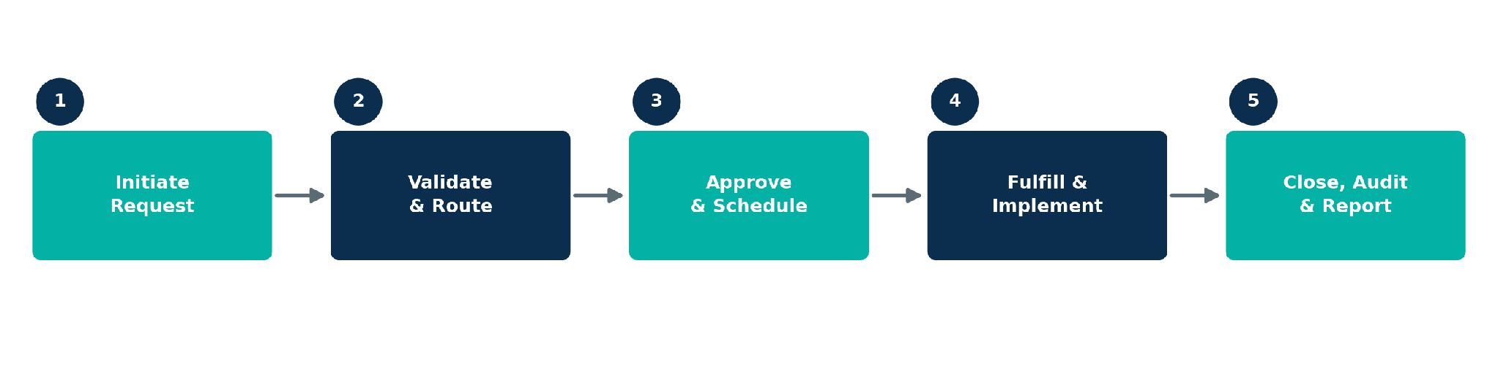
Project Documentation
Prepared for: Network Operations & ITSM Platform Team
Platform: ServiceNow (ITSM / Change Management / Orchestration)
Document Type: Project Overview & Process Journey Map
Version: 1.0

1. Project Overview
Automating network request management in ServiceNow enhances operational efficiency by streamlining workflows, reducing manual interventions, and ensuring real-time updates. The objective of this project is to implement a fully automated and scalable network change management process in ServiceNow that automates user-initiated network requests, ensures rapid fulfillment, maintains audit-ready change records, and provides accurate configuration tracking.

1.1 Business Objectives
- Reduce manual intervention across the network request lifecycle through automated workflows.
- Accelerate request fulfillment turnaround time while maintaining accuracy and control.
- Ensure every change is audit-ready with a complete, traceable record from request to closure.
- Maintain accurate, real-time configuration data through automated CMDB updates.
- Provide end users and stakeholders with real-time visibility into request and change status.
- Build a scalable process that supports growing volumes of network change requests.

1.2 Scope
This initiative covers the end-to-end lifecycle of a user-initiated network request within ServiceNow — from initial submission through validation, approval, automated fulfillment, and closure with audit reporting. It spans the ServiceNow Service Portal, Change Management, CMDB, Orchestration / IntegrationHub, and Performance Analytics modules.

1.3 Key Stakeholders
- End Users / Requesters — employees or teams submitting network change requests.
- Network Engineers — responsible for reviewing and implementing network configuration changes.
- Change Approvers / CAB — validate risk and authorize scheduled changes.
- ServiceNow Platform Team — owns workflow design, automation, and system integrations.
- Compliance / Audit Team — relies on accurate, audit-ready change records.

1.4 Process Snapshot

The process is organized into five automated stages — Initiate Request, Validate & Route, Approve & Schedule, Fulfill & Implement, and Close, Audit & Report — detailed in the journey map on the following page.

3. Key Automation Opportunities Summary
The table below consolidates the highest-value automation opportunities identified across the journey, to be prioritized in the implementation phase.
Stage | Priority Automation Opportunity
Initiate Request | Introduce a Virtual Agent to recommend the correct request type
Validate & Route | Expand real-time CMDB/topology integration
Approve & Schedule | Add automatic escalation to backup approvers
Fulfill & Implement | Build automated rollback playbooks for failed changes
Close, Audit & Report | Add a post-closure satisfaction survey / feedback loop

3.1 Expected Outcomes
- Faster end-to-end turnaround for network change requests through reduced manual handling.
- Consistent, audit-ready records for every change, supporting compliance and audit readiness.
- Accurate, real-time CMDB configuration tracking aligned to actual network state.
- A scalable workflow architecture able to absorb growing request volumes without added headcount.
AUTOMATED NETWORK REQUEST MANAGEMENT
2. Process Journey Map
Scenario: A network engineer or business user requests a network change — such as VLAN provisioning, firewall access, or port configuration — through ServiceNow, from initial submission through automated fulfillment and audit-ready closure.
STAGE | 1 Initiate Request | 2 Validate & Route | 3 Approve & Schedule | 4 Fulfill & Implement | 5 Close, Audit & Report
  Process Steps  What does the requester or system experience? | • User identifies a network need (e.g., new VLAN, firewall rule, port access)  • Logs into the ServiceNow Service Portal  • Selects the Network Request catalog item and completes the guided form | • System runs automated validation (duplicate check, mandatory fields, CMDB correlation)  • Request auto-classified by network domain (LAN / WAN / Firewall / Wireless)  • Routed automatically to the correct fulfillment queue | • Change workflow triggers automatically based on risk/type  • Approvers notified via email and mobile app  • Approve or reject with comments; change added to the Change Calendar | • Orchestration triggers automated network configuration  • Change executed via automation tooling (e.g., Ansible / IntegrationHub)  • CI records updated automatically; post-change validation tests run | • Requester notified automatically of completion  • Request closed with full audit trail attached  • Audit-ready change record generated; dashboards updated
  System Interactions  What tools, people, and data are involved? | • ServiceNow Service Portal  • Network Request catalog item  • Guided dynamic request form  • Knowledge base articles | • Flow Designer / IntegrationHub  • Configuration Management Database (CMDB)  • Business rules & assignment rules engine | • ServiceNow Change Management module  • Automated approval workflow  • Mobile push notifications  • Change Calendar / collision detection | • ServiceNow Orchestration / IntegrationHub  • Network automation & scripting tools  • Automated CMDB update  • Post-implementation verification checks | • Automated notifications (portal / email)  • Change & audit record repository  • Performance Analytics dashboards  • Compliance reporting
  Goals & Motivations  “Help me...” / “Help me avoid...” | • Help me quickly find the right request type  • Help me avoid submitting an incomplete or incorrect request | • Help me ensure the request reaches the right team without delay  • Help me avoid manual triage errors | • Help me review and decide quickly  • Help me avoid conflicting or unauthorized changes | • Help me implement the change correctly the first time  • Help me avoid downtime or configuration drift | • Help me confirm my request was completed successfully  • Help me maintain accurate, compliant records for audits
  Positive Moments  What works well at this stage? | • Guided, structured forms reduce input errors  • Clear catalog categories speed up request creation | • Instant validation feedback with no duplicate manual re-entry  • Automatic routing removes queue guesswork | • Mobile approvals speed up decision turnaround  • Built-in collision detection improves change visibility | • Automation shortens fulfillment time and reduces manual error  • Configurations stay consistent across the environment | • Instant closure confirmation builds user confidence  • Ready-made audit trail simplifies compliance reviews
  Negative Moments / Pain Points  What causes friction or delay? | • Users are sometimes unsure which catalog item applies to their need  • Missing details trigger manual follow-up | • Incomplete CI data causes routing exceptions  • Legacy requests sometimes need manual reclassification | • Approvals can stall when approvers are unavailable  • Risk assessment can be unclear for complex changes | • Automation failures can require manual rollback  • Occasional gaps in CMDB reconciliation after execution | • Users are sometimes unsure who to contact after closure  • Some reporting still requires manual compilation
  Areas of Opportunity  How might we improve this stage? | • Introduce a Virtual Agent to recommend the correct request type  • Auto-populate fields using existing CMDB/user data | • Expand real-time CMDB/topology integration  • Apply ML-based auto-classification for edge cases | • Add automatic escalation to backup approvers  • Introduce data-driven risk scoring from change history | • Build automated rollback playbooks for failed changes  • Add real-time CMDB reconciliation checks post-fulfillment | • Add a post-closure satisfaction survey / feedback loop  • Deliver real-time SLA and compliance dashboards

